
C H A P T E R 9

The Knee
Cynthia C. Norkin, PT, EdD

Structure and Function

Tibiofemoral and Patellofemoral Joints
The knee is composed of two distinct articulations enclosed within a single joint capsule: the tibiofemoral joint and the patellofemoral joint. At the tibiofemoral joint, the proximal joint surfaces are the convex medial and the lateral condyles of the distal femur (Fig. 9.1). Posteriorly and inferiorly, the


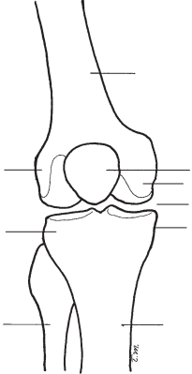

Femur
Lateral condyle
Patella
Medial condyle

Medial condyle
Tibiofemoral joint
Lateral condyle
Intercondylar tubercles
Fibula

Tibia
FIGURE 9.1 An anterior view of a right knee showing the tibiofemoral joint.

longer medial condyle is separated from the lateral condyle by a deep groove called the intercondylar notch. Anteriorly, the condyles are separated by a shallow area of bone called the femoral patellar surface. The distal articulating surfaces are the two shallow concave medial and lateral condyles on the proximal end of the tibia. Two bony spines called the intercondylar tubercles separate the medial condyle from the lateral condyle. Two joint discs called menisci are attached to the articulating surfaces on the tibial condyles (Fig. 9.2). At the patellofemoral joint, the articulating surfaces are the pos- terior surface of the patella and the femoral patellar surface (Fig. 9.3).
The joint capsule that encloses both joints is large, loose, and reinforced by tendons and expansions from the surround- ing muscles and ligaments. The quadriceps tendon, patellar ligament, and expansions from the extensor muscles pro- vide anterior stability (see Fig. 9.3). The lateral and medial

Anterior cruciate ligament
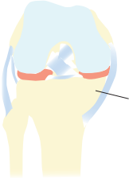
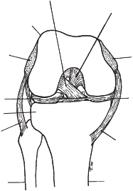
Posterior cruciate ligament
epicondyle
Lateral
Medial epicondyle
Lateral condyle
Medial condyle
Medial meniscus
meniscus
Lateral
Lateral condyle
Medial condyle
Lateral (fibular)
collateral ligament
Medial (tibial)
collateral ligament
Fibula
Femur

Tibia
FIGURE 9.2 An anterior view of a right knee in the flexed position showing femoral and tibial condyles, medial and lateral menisci, and cruciate and collateral ligaments.

316 PART III Lower-Extremity Testing

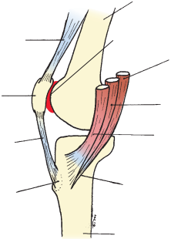
Femur

Patellar
quadriceps tendon
Patellofemoral joint
Semitendinosus
Patella
Gracilis

Sartorius
Patellar ligament

Pes anserinus
Tibial
tuberosity

Tibia
FIGURE 9.3 A view of a right knee showing the medial
aspect, where the cut tendons of the three muscles that
insert into the anteromedial aspect of the tibia make up the pes anserinus. Also included are the patellofemoral joint, the patellar ligament, and the patellar tendon.

collateral ligaments,iliotibialband, and pes anserinus help to provide medial–lateral stability, and the knee flexors help to provide posterior stability. In addition, the tibiofemoral joint is reinforced by the anterior and posterior cruciate ligaments, which are located within the joint (see Fig. 9.2).
Osteokinematics
The tibiofemoral joint is a double condyloid joint with 2 degrees of freedom. Flexion–extension occurs in the sagit- tal plane around a medial–lateral axis and rotation occurs in the transverse plane around a vertical (longitudinal) axis.1 The incongruence and asymmetry of the tibiofemoral joint surfaces combined with muscle activity and ligamentous restraints produce an automatic rotation. This automatic rotation is involuntary and occurs primarily toward the end of extension when motion stops on the shorter lateral femoral condyle but continues on the longer medial condylar surface. During the last portion of the active extension range of motion (ROM)

automatic rotation produces what is referred to as the screw- home mechanism, or “locking,” of the knee. For example, during non-weight-bearing active knee extension with the tibia moving on the femur, the tibia laterally rotates during the last 10 to 15 degrees of extension to lock the knee.2 Therefore, in the fully extended position of the knee, the tibia is laterally rotated in relation to the femur. To unlock the knee, either the tibia has to rotate medially or the femur has to rotate laterally.
This automatic rotation is not under voluntary control and should not be confused with the voluntary rotation that is possible when the knee is flexed. At 90 degrees of flexion the greatest range of tibial rotation is possible.3,4 In a study by Almquistand colleagues of 120 healthy individuals (60 males and 60 females), about 40% of the total voluntary knee rota- tion was estimated as being internal rotation and 60% as external rotation.5
Arthrokinematics
In non-weight-bearing active motion, the concave tibial articulating surfaces slide on the convex femoral condyles in the same direction as the movement of the shaft of the tibia. The tibial condyles slide posteriorly on the femoral condyles during flexion and the tibial condyles slide anteriorly on the femoral condyles during extension.
In a weight-bearing situation the larger articulating sur- faces of the convex femoral condyles must roll and slide in opposite directions to remain on the smaller tibial surfaces. During weight-bearing flexion, the femoral condyles roll posteriorly and slide anteriorly. The menisci follow the roll of the condyles by distorting posteriorly in flexion. In exten- sion, the femoral condyles roll anteriorly and slide poste- riorly.1 In the last portion of extension, motion stops at the lateral femoral condyle, but sliding continues on the medial femoral condyleto produce locking of the knee.
The patella slides superiorly in extension and inferiorly in flexion. Some patellar rotation and tilting accompany the sliding during flexion and extension.
Capsular Pattern
The capsular pattern at the knee is characterized by a smaller limitation of extension than of flexion and no restriction of rotations.6,7 Fritz and associates8 found that patients with a capsular pattern, defined as a ratio of extension loss to flex- ion loss between 0.03 and 0.50, were 3.2 times more likely to have arthritis or arthroses of the knee.

CHAPTER 9 The Knee 317

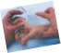
RANGE OF MOTION TESTING PROCEDURES: Knee
Range of Motion Testing Procedures/KNEE

Landmarks for Testing Procedures
L
Figure 9.4 provides a red dot at the center of the knee joint where the body of a goniometer should be cen- tered. The red dots at the hip and ankle indicate sites where the arms of the goniometer should be aligned. In Figure 9.5, the anatomical landmarks are identiﬁed, that is, the lateral femoral epicondyle where the body of the goniometer should be placed and the goniometer arm placements at the greater trochanter at the hip and the lateral malleolus at the ﬁbula.

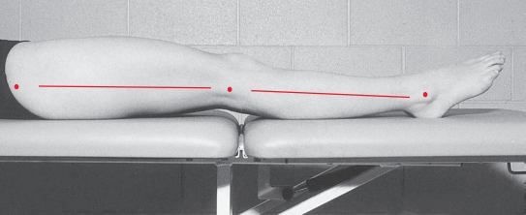
FIGURE 9.4 A lateral view of the right lower extremity showing surface anatomy landmarks for goniometer alignment.

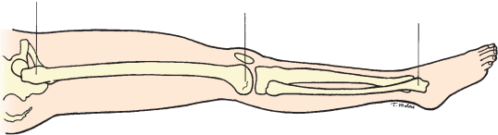
Greater trochanter
of femur Lateral femoral
epicondyle Lateral malleolus
of fibula
FIGURE 9.5 A lateral view of the right lower extremity showing bony anatomical landmarks

for goniometer alignment for measuring knee flexion ROM.

318 PART III Lower-Extremity Testing

KNEE FLEXION
Motion occurs in the sagittal plane around a medial–
lateral axis. The normal range of ﬂexion for adults varies from 130 to 140 degrees.9,10 However, according to the sixth edition of the AMA’s Guides to the Evaluation of Permanent Impairment, a knee ﬂexion range of greater than 110 degrees is considered normal;11 this deﬁnition of a normal range of motion is quite broad and not
in agreement with other investigators. Please refer to Tables 9.1 through 9.3 in the Research Findings section for additional normal ROM values by age and gender.
Testing Position
Place the individual supine, with the knee in extension. Position the hip in 0 degrees of extension, abduction, and adduction. Place a towel roll under the ankle to
allow the knee to extend as much as possible.
Stabilization
Stabilize the femur to prevent rotation, abduction, and adduction of the hip.
Testing Motion
Hold the ankle in one hand and the anterior thigh with the other hand. Move the individual’s thigh to

approximately 90 degrees of hip ﬂexion and move
the knee into ﬂexion (Fig. 9.6). Stabilize the thigh to
prevent further hip motion and guide the lower leg
into knee ﬂexion. The end of the range of knee ﬂexion occurs when resistance is felt and attempts to over-
come the resistance cause additional hip ﬂexion.

Normal End-Feel
Usually, the end-feel is soft because of contact
between the muscle bulk of the posterior calf and
the thigh or between the heel and the buttocks. The end-feel may be ﬁrm because of tension in the vas- tus medialis, vastus lateralis, and vastus intermedialis muscles.
Goniometer Alignment
See Figures 9.7 and 9.8.
1. Center fulcrum of the goniometer over the lateral epicondyle of the femur.
2. Align proximal arm with the lateral midline of the femur, using the greater trochanter for reference.
3. Align distal arm with the lateral midline of the ﬁb- ula, using the lateral malleolus and ﬁbular head for reference.

Range of Motion Testing Procedures/KNEE

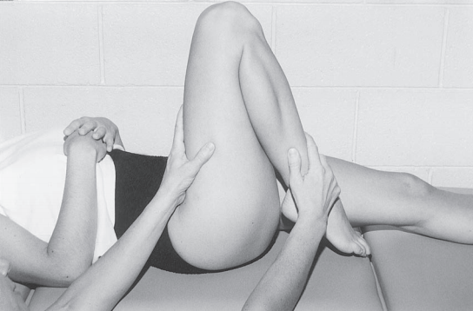
FIGURE 9.6 The right lower extremity at the end of knee flexion ROM. The examiner
uses one hand to move the individual’sthigh to approximately 90 degrees of hip flexion and then stabilizes the femur to prevent further flexion. The examiner’sother hand
guides the lower leg through full knee flexion ROM.

Range of Motion Testing Procedures/KNEE

CHAPTER 9 The Knee 319

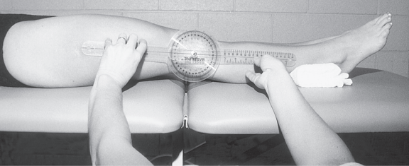
FIGURE 9.7 In the starting position for measuring knee flexion ROM, the individual is
supine with the upper thigh exposed so that the greater trochanter can be visualized and palpated. A towel roll is placed under the ankle to elevate the lower leg so that the full beginning ROM can be measured. The examiner either kneels or sits on a stool to align and read the goniometer at eye level.

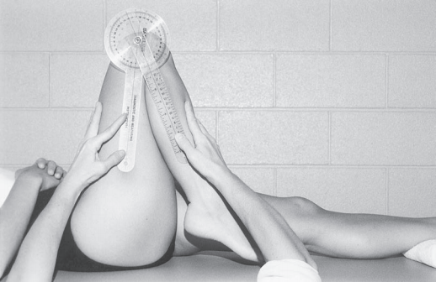
FIGURE 9.8 At the end of the knee flexion ROM, the examiner uses one hand to maintain knee flexion and also to align the distal arm of the goniometer with the lateral midline of the leg.

Measurements of knee ﬂexion taken in a squatting position have been found to be greater than mea- surements taken in the supine position; therefore, it has been suggested by some researchers that per- haps measurements should be made in a squatting position for individuals who are capable of assuming

that position.12 However, caution should be used
when asking individuals to assume a squatting posi- tion. If strength, balance, and joint integrity issues are present, there is a risk of falling and joint injury. The supine, non-weight-bearing position is considered a safer position for many individuals.

Range of Motion Testing Procedures/KNEE

320 PART III Lower-Extremity Testing

KNEE EXTENSION
Knee extension occurs in the sagittal plane around
a medial-lateral axis and is usually recorded as the
starting position for knee ﬂexion ROM. Normal knee extension ROM values for adults are about 0 degrees. An extension limitation is present when the starting
position for ﬂexion ROM does not begin at 0 degrees but is in some amount of ﬂexion. When extension
goes beyond the 0 starting position, it may be within the normal limits of 5 to 10 degrees in children, but
when it exceeds 5 or more degrees in adults,1,2 it
is called hyperextension or genu recurvatum. See
Research Findings and Tables 9.1 to 9.4 for more infor- mation by age groups from neonates to older adults.
Testing Position
Place the individual supine in the 0 starting position
for measuring knee ﬂexion. Place a folded towel under the ankle to ensure that the knee is in full extension.
Stabilization
Stabilize the femur to keep the hip in neutral abduc- tion, adduction, and rotation.
Testing Motion
To determine whether hyperextension is present, the examiner should place one hand on top of the lower thigh and exert a slight downward pressure.
Normal End-Feel
The end-feel is ﬁrm because of tension in the poste- rior joint capsule, the oblique and arcuate popliteal

ligaments, the collateral ligaments, and the anterior and posterior cruciate ligaments.
Goniometer Alignment
1. Center fulcrum of the goniometer over the lateral epicondyle of the femur.
2. Align proximal arm with the lateral midline of the femur, using the greater trochanter for reference.
3. Align distal arm with the lateral midline of the ﬁb- ula, using the lateral malleolus and ﬁbular head for reference.
See Appendix B for a summary guide for measure- ment of knee ROM using a universal goniometer.

KNEE ROTATION
At this time, we are not able to recommend measuring voluntary knee rotation in the clinical setting because most methods for measuring rotational laxity are still in various stages of development.13–16 Three of these
methods have been tested for reliability with accept- able results.13,15,16
The only practical method that could be used in
the clinical setting is the one used by Clarkson,17 who measured total active tibial rotation ROM with the
individual in a sitting position with the knee ﬂexed
to 90 degrees. An OB Myrin compass inclinometer
was strapped on the tibia and the mean total ROM
was given as 40 degrees in women and 58 degrees in men. However, the reliability and validity of this testing method were not reported.

CHAPTER 9 The Knee 321

MUSCLE LENGTH TESTING PROCEDURES: Knee
Muscle Length Test ing Procedures/KNEE

Landmarks for Testing Procedures
L
Se Fi
See Figures 9.4 and 9.5.

Knowledge of gross anatomy and physiology is essen- tial for the identiﬁcation of the structures that may be responsible for impaired ROM. Muscle length testing can help to differentiate ROM limitations caused by
three muscles are all passively lengthened by knee
ﬂexion regardless of the position of the hip. The length of these muscles is automatically tested along with other joint structures during the measurement of knee ﬂexion (in which the hip is ﬂexed); therefore, a separate test has not been included.
one-joint muscle from limitations caused by two-joint muscles. Isolated ROM testing of one joint at a time

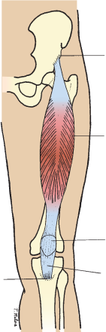
is necessary to determine whether a particular motion is being limited by joint structures and muscles that
cross only one joint. To determine whether a muscle or muscles that cross more than one joint are causing the limitation, muscles must be stretched over all joints
crossed.
Anterior inferior iliac spine
KNEE EXTENSORS
The major knee extensor is the quadriceps femoris,
which consists of the following four muscles: rectus
femoris, vastus medialis, vastus lateralis, and vastus
intermedius. The rectus femoris is the only one of the four muscles that crosses both the hip and the knee
Rectus femoris
joints. It arises proximally from two tendons: an ante- rior tendon from the anterior inferior iliac spine and a posterior tendon from a groove superior to the brim of the acetabulum. The three vastus muscles originate on the femur and merge with the rectus femoris in
a thick, ﬂat common tendon called the quadriceps
tendon, which inserts into the proximal aspect of the patella. The quadriceps tendon continues distally over the patella to attach to the apex of the patella. The
Patella
part of the quadriceps tendon that continues distal to the patella to attach to the tibial tuberosity is known as the patella tendon or ligament (Fig. 9.9).
Patellar ligament
Tibial tuberosity
When the rectus femoris muscle contracts, it ﬂexes the hip and extends the knee. If the rectus femoris mus- cle is short and knee ﬂexionis attempted, the hip pas-
sively moves into ﬂexion to accommodate the shortened muscle. The three vastus muscles also produce active
FIGURE 9.9 An anterior view of the left lower extremity showing the attachments of the rectus femoris muscle.
knee extension but cross only the knee joint. These

322 PART III Lower-Extremity Testing

ELY TEST
The Ely test is used to evaluate the length of the rec- tus femoris muscle by positioning the hip in 0 degrees of ﬂexion and then ﬂexing the knee.
Testing Position
Place the individual prone, with both feet off the end of the examining table. Extend the knees and position the hips in 0 degrees of ﬂexion, extension, abduction, adduction, and rotation (Fig. 9.10). If pain is present from pressure on the patella, a small towel roll may be placed under the distal femur to slightly elevate the
thigh, thus reducing contact between the patella and the examining table.
Stabilization
Stabilize the hip to maintain the neutral position. Do not allow the hip to ﬂex.
Testing Motion
Flex the knee by lifting the lower leg off the table
(Figs. 9.11 and 9.12). The end of the ROM occurs
when resistance is felt from tension in the anterior thigh and further knee ﬂexion causes the hip to ﬂex.

Goniometer Alignment
See Figure 9.13.
1. Center fulcrum of the goniometer over the lateral epicondyle of the femur.
2. Align proximal arm with the lateral midline of the femur, using the greater trochanter as a reference.
3. Align distal arm with the lateral midline of the ﬁb- ula, using the lateral malleolus and the ﬁbular head for reference.
Interpretation
If the knee can be ﬂexed to at least 90 degrees with the hip in the neutral position, the length of the rectus femoris is considered normal. In a study by Gnat
and colleagues,18 14 students were selected from a
healthy university student group of 30. Passive knee ﬂexion positioning was prone on a table with a goni- ometer fastened to the lower leg at a point halfway
between the apex of the patella and the line joining the two malleoli. A force gauge was fastened around the ankle. Extrapolating from the graph created by
Gnat et al, it appears that ROM was between 125 and 132 degrees.

Normal End-Feel

Muscle Length Test ing Procedures/KNEE
The end-feel is ﬁrmowing to tension in the rectus femoris muscle.

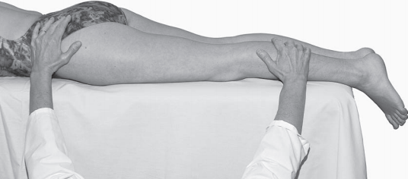
FIGURE 9.10 The individual is in the prone starting position for testing the length of the rectus femoris muscle.

Muscle Length Test ing Procedures/KNEE

CHAPTER 9

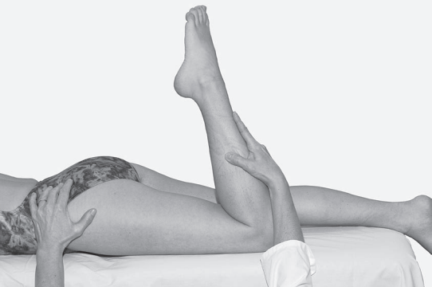

FIGURE 9.11 A lateral view of the individual at the end of the testing motion for the length of the left rectus femoris muscle.

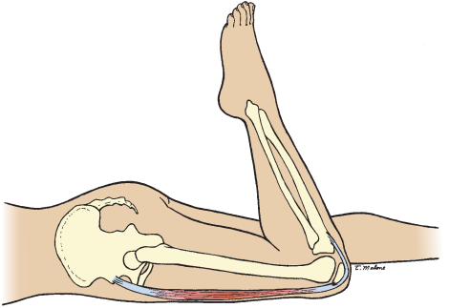
FIGURE 9.12 A lateral view of the left rectus femoris muscle being stretched over the hip and knee joints at the end of the testing motion.

The Knee 323

Muscle Length Test ing Procedures/KNEE

324 PART III Lower-Extremity Testing

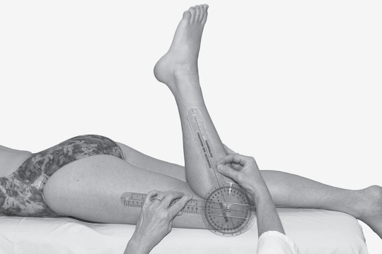
FIGURE 9.13 Goniometer alignment for measuring the position of the knee at the end of the Ely Test.

CHAPTER 9 The Knee 325

KNEE FLEXORS
The hamstring muscles are composed of the semi-
tendinosus, semimembranosus, and biceps femoris
(long and short heads). The semitendinosus, semi-
membranous, and long head of the biceps femoris,
cross both the hip and the knee joints. The prox-
imal attachment of the semitendinosus is on the
ischial tuberosity, and the distal attachment is on the
proximal aspect of the medial surface of the tibia
(Fig. 9.14A). The proximal attachment of the semi-
membranosus is also on the ischial tuberosity, and the distal attachment is on the medial aspect of the medial tibial condyle (Fig. 9.14B). The biceps femoris muscle

arises from two heads; the long head attaches to the ischial tuberosity and the sacrotuberous ligament,
Muscle Length Test ing Procedures/KNEE
whereas the short head attaches to the femur along the lateral lip linear aspera and lateral supracondylar line, and the lateral intermuscular septum. The distal attachments of the biceps femoris are on the head of the ﬁbula, with a small portion attaching to the lateral tibial condyle and the lateral collateral ligament (see Fig. 9.14A).
When the hamstring muscles contract, they extend the hip and ﬂex the knee. These muscles are passively lengthened by placing the hip in ﬂexion and the knee in extension.

Ischial tuberosity
Ischial tuberosity
Semitendinosus
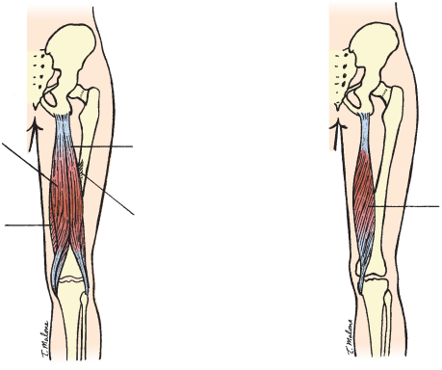
Biceps femoris (long head)

Semimembranosus
Semimembranosus
Biceps femoris (short head)

fibula
Head of
Head of fibula
Tibia
Tibia

A B
FIGURE 9.14 (A) A posterior view of the thigh showing the attachments of the
semitendinosus and the biceps femoris muscles. (B) A posterior view of the thigh
showing the attachments of thesemimembranosus muscle, which lies under the two hamstring muscles shown in part A.

326 PART III Lower-Extremity Testing

DISTAL HAMSTRING LENGTH TEST
The distal hamstring length test or hamstring passive knee extension (PKE) test is also called the popliteal angle (PA) test because the angle that is being mea- sured is the popliteal angle between the femur and the lower leg.
Testing Position
Position the individual supine with the hip on the side being tested in 90 degrees of ﬂexion and 0 degrees of abduction, adduction, and rotation (Fig. 9.15). Initially, the knee being tested is allowed to relax in ﬂexion.
The lower extremity that is not being tested rests
on the examining table with the knee fully extended and the hip in 0 degrees of ﬂexion, extension, abduc- tion, adduction, and rotation.
Stabilization
Stabilize the femur to prevent rotation, abduction, and adduction at the hip and to maintain the hip in 90 degrees of ﬂexion.

Testing Motion
Extend the knee to the end of the ROM. The end of the testing motion occurs when resistance is felt from tension in the posterior thigh and further knee extension causes the hip to move toward extension (Figs. 9.16 and 9.17).
Normal End-Feel
The end-feel is ﬁrmowing to tension in the semi- membranosus, semitendinosus, and biceps femoris muscles.
Goniometer Alignment
See Figure 9.18.
1. Center fulcrum of the goniometer over the lateral epicondyle of the femur.
2. Align proximal arm with the lateral midline of the femur, using the greater trochanter for a reference.
3. Align distal arm with the lateral midline of the ﬁb- ula, using the lateral malleolus and ﬁbular head for reference.

Muscle Length Test ing Procedures/KNEE

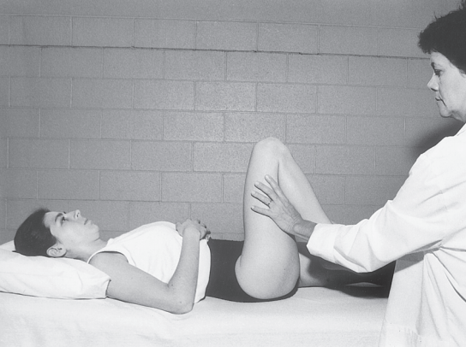
FIGURE 9.15 Starting position for measuring the length of the hamstring muscles.

Muscle Length Test ing Procedures/KNEE

CHAPTER 9 The Knee 327

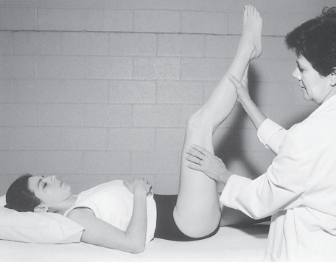
FIGURE 9.16 End of the testing motion for the length of the right hamstring muscles.

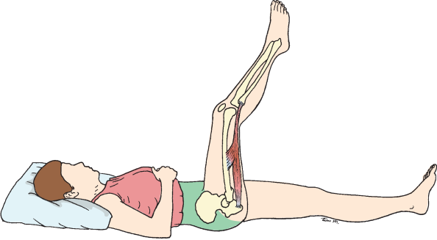
FIGURE 9.17 A lateral view of the right lower extremity shows the hamstring muscles being stretched over the hip and knee joints at the end of the testing motion.

328 PART III Lower-Extremity Testing

Interpretation
Gajdosik and associates,19 in a study of 30 healthy males aged 18 to 40 years, found a mean value of
31 degrees (standard deviation [SD] = 7.5 degrees). Some researchers have reported the supplementary angles to those noted by Gajdosik and associates.
Youdas and colleagues20 used a 360-degree universal goniometer to measure the popliteal angle (PA) in
214 individuals (108 women and 106 men) between
the ages of 20 and 79 years. The mean value for the women of 152.0 degrees (SD = 10.6 degrees) was
greater than the mean value for men of 141.4 degrees (SD = 8.1 degrees). The supplementary angles
of these values for women and men are 28.0 and
38.6 degrees, respectively, which is generally
consistent with the values noted by Gajdosik and associates.19

Gnat and associates18 investigated the interrater and test-retest reliability of a modiﬁed version of the passive knee extension (PKE) test used to evaluate
muscle length. Passive knee extension positioning was supine, with a belt securing the pelvis and the goni-
ometer fastened to the lower leg at a point halfway
between the apex of the patella and a line joining the two malleoli. A force gauge was fastened at the ankle.
Two testers in a study by Fredriksen and col-
leagues21 found that PKE angle measurements for a
single female subject tested 16 times per side ranged from 153 to 159 degrees for the left leg and from 154 to 165 degrees for the right leg. A standardized force using a dynamometer was used to extend the knee
and the hip was positioned in 120 degrees of ﬂexion, which is considerably larger than the 90 degrees of hip ﬂexion used by both Youdas20 and Gadjosik.19

Muscle Length Test ing Procedures/KNEE

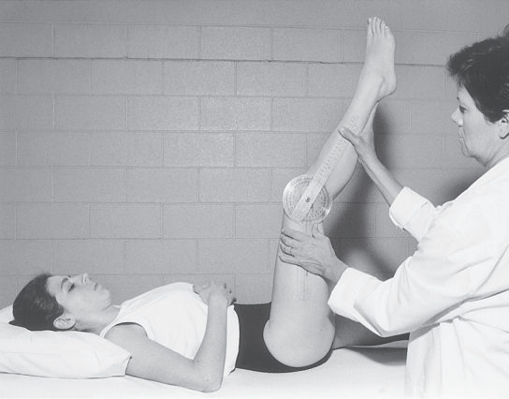
FIGURE 9.18 Goniometer alignment for measuring knee position at the end of the Distal Hamstring Length Test. This test is also called the Popliteal Angle Test.

Research Findings

This section of the chapter includes not only age and gender effects on knee ROM but also the effects of body mass. In addition, functional knee ROM required for stairs and other activities of daily living is followed by a sampling of reli- ability and validity studies in normal and patient populations. Table 9.1 provides knee flexion ROM values for adults from selected sources. Tables 9.2 through 9.4 provide information on neonates, normative values for infants and young children, and age effects on knee flexion ROM.

Effects of Age, Gender, and Other Factors
Age
Knee extension limitations of 15 to 20 degrees at birth are normal and similar to extension limitations found at the hip joint at birth. The term “extension limitation” is used rather than “flexion contracture” because contracture refers to an abnormal condition caused by fixed muscle shortness, which may be permanent.22 Knee extension limitations in the neo- nate gradually disappear by about 12 or 13 years of age and extension, instead of being limited, may become excessive in the toddler. More details of research studies are provided below and in Tables 9.2 through 9.4.
Waugh and colleagues23 and Drews and coworkers24 found that newborns lacked approximately 15 to 20 degrees

CHAPTER 9 The Knee 329
of knee extension. Schwarze and Denton,25 in a study of 1,000 neonates (527 girls and 473 boys) in the first 3 days of life, found a mean extension limitation of 15 degrees. These find- ings agree with the findings of Wanatabe and associates,26 who found that newborns lacked 14 degrees of knee extension. The extension limitation gradually disappears with increasing age, as shown by comparing Tables 9.2 and 9.3.
Broughton, Wright, and Menelaus27 measured extension limitations in normal neonates at birth and again at 3 months and 6 months. At birth, 53 of the 57 (93%) neonates had exten- sion limitations of 15 degrees or greater, whereas only 30 of 57 (53%) infants had extension limitations at 6 months of age. The mean reduction in extension limitations was 3.5 degrees per month from birth to 3 months and 2.8 degrees between 3 and 6 months (see Tables 9.2 and 9.3). The 2-year-olds in the study conducted by Wanatabe and associates26 had no evi- dence of a knee extension limitation (see Table 9.3)
Knee extension beyond 0 degrees (often referred to as hyperextension) is considered a normal finding in young children but is not usually observed in adults,3 who may have slightly less than full knee extension. Wanatabe and associates26 found that the 2-year-olds had up to 5 degrees of extension beyond 0. This finding is similar to the mean of 5.4 degrees of extension beyond 0 noted by Boone28 for a group of children between 1 and 5 years of age. Beighton, Sol- omon, and Soskolne,29 in a study of joint laxity in 1,081 males and females, found that joint laxity decreased rapidly through- out childhood in both genders and decreasedat a slower rate during adulthood. The authors used a ROM of greater than

TABLE 9.1 Knee Flexion ROM in Adults: Normal Values in Degrees
 | Boone9 | Roach and Miles10 |  | Soucie32
 |  | Males and | Males and
Gender, | Males | females | females | Females | Males | Females | Males
Age Range, | 20–54 yr | 40–59 yr | 60–74 yr | 20–44 yr | 20–44 yr | 45–69 yr | 45–69 yr
Sample | n = 56 | n = 727 | n = 523 | n = 143 | n = 114 | n = 123 | n = 96
Motion | Mean (SD) | Mean (SD) | Mean (SD) | Mean (SD) | Mean (SD) | Mean (SD) | Mean (SD)
Flexion | 141.0 (5.4) | 132.0 (11.0) | 131.0 (11.0) | 141.9 (6.3) | 137.7 (6.5) | 137.8 (7.4) | 132.9 (6.3)
SD = Standard deviation.


TABLE 9.2 Knee Extension Limitations in Neonates 6 Hours to 7 Days of Age: Normal Values in Degrees

 | Waugh et al23 | Drews et al24 | Schwarze and Denton25 | Broughtonetal27
Age Range | 6–65 hr | 12 hr–6 days | 1–3 days | 1–7 days
Sample | n = 40 | n = 54 | n = 1,000 | n = 57
Motion | Mean (SD) | Mean (SD) | Mean | Mean (SD)
Extension limitation | 15.3 (9.9) | 20.4 (6.7) | 15.0 | 21.4 (7.7)

SD = standard deviation.
All values were obtained from passive ROM measurements with use of a universal goniometer.

330 PART III Lower-Extremity Testing

TABLE 9.3 Knee Range of Motion in Infants and Young Children 0 to 12 Years of Age: Normal Values in Degrees
 | Broughtonetal27 |  | Wanatabeet al26 |  | Boone28
Age | 3 mo | 6 mo | 0–2 yr |  | 1–5 yr | 6–12 yr
Sample | n = 57 | n = 57 | n = 109 |  | n = 19 | n = 17
Motion | Mean (SD) | Mean (SD) | Range of Means |  | Mean (SD) | Mean (SD)
Flexion | 145.5 (5.3) | 141.7 (6.3) | 148–159 |  | 141.7 (6.2) | 147.1 (3.5)
Extension | 10.7 (5.1)* | 3.3 (4.3)* | 5.0† |  | 5.4 (3.1)† | 0.4 (0.9)
SD = standard deviation.  *Indicates extension limitations.  †Indicates extension beyond 0 degrees.  10 degrees of knee extension beyond 0 as one of the criteria of joint laxity. Cheng, Chan, and Hui,30 in a study of 2,360 Chinese children, found that the average of 16 degrees of knee extension beyond 0 in children of 3 years of age decreased to 7 degrees by the time the children reached 9 years of age.  Steinberg and colleagues,31 in a study of 1,320 female dancers between the ages of 8 and 16 years of age and a con- trol group of 226 nondancers of similar age, found that knee flexion ROM showed a small but significant decrease with increasing age in both groups. The authors suggested that the decreases in ROM might be related to a general increase in circumference in thigh and leg muscles that developed as the group matured and as subcutaneous fat was deposited. However, the decrease in ROM in nondancers appeared to be larger (15 degrees) than in dancers, which might be accounted for by the fact that the dancers were probably more active than the nondancers.  Soucie and colleagues32 obtained bilateral passive knee ROM measurements on males and females in each of seven age-groups for a total of 674 healthy male and female individ- uals with a mean age of 33 years. Subjects were predominately white and included slightly more females than males. The authors found that joint ROM tended to decline with advanc- ing age with the greatest difference between children (aged 2 to 8 years) and all other age-groups. The largest age-related |  |  |  | difference between young and old was a 15-degree difference in mean knee flexion ROM between the 2-year-old group and the group aged 45 to 69.32  Also, a comparison of knee extension beyond 0 mean values for the group aged 13 to 19 years can be found in Table 9.4. Table 9.3 has extension values for the group aged 1 to 5 years, which demonstrates the decrease in knee exten- sion beyond 0 that occurs in childhood.  Walker and colleagues33 studied active ROM of the extremity joints in 30 men and 30 women (ranging in age from 60 to 84 years) from recreational centers. No differences were found in knee ROM between subjects aged 60 to 69 years and subjects aged 75 to 84 years. However, average values indicated that the subjects had an extension limitation (inabil- ity to attain a neutral 0-degree starting position). This finding was similar to the loss of extension noted at the hip, elbow, and first metatarsophalangeal joints. The 2-degree extension limitation found at the knee was much smaller than that found at the hip joint. According to the American Association of Orthopaedic Surgeons (AAOS) handbook,34 extension limita- tions of 2 degrees are considered normal in adults. Extension limitations greater than 5 degrees in adults maybe considered as knee flexion contractures. These contractures often occur in the elderly because of disease, sedentary lifestyles, and the effects of the aging process on connective tissues.
TABLE 9.4 Age Effects on Knee Flexion in Individuals 2 to 74 Years of Age: Mean Values in Degrees
 | Soucie32* | Boone28 |  |  | Roach and Miles10
Age | 2–8 yr | 13–19 yr |  | 20–29 yr | 40–59 yr | 60–74 yr
Sample | n = 39 | n = 17 |  | n = 19 | n = 727 | n = 523
Motion | Mean (SD) | Mean (SD) |  | Mean (SD) | Mean (SD) | Mean (SD)
Flexion | 152.6 (4.5) | 142.9 (3.7) |  | 140.2 (5.2) | 132.0 (11.0) | 131.0 (11.0)
Extension | 5.4 (4.9) | 0.0 (0.0) |  | 0.4 (0.9)
SD = Standard deviation. *Females.

CHAPTER 9 The Knee 331

Mollinger and Steffan35 used a universal goniometer (UG) to assess knee ROM among 112 nursing home residents with an average age of 83 years. The authors found that only 13% of the subjects had full (0-degree) passive knee extension bilaterally. Thirty-seven of the 112 subjects (33%) had bilat- eralknee extension limitations of 5 degrees or less, which the AAOS considers normal in older adults. Forty-seven subjects (42%) had greater than 10 degrees of limitations in extension (flexion contractures). Residents with a 30-degree loss of knee extension had an increase in resistance to passive motion and a loss of ambulation.
Steultjens and coworkers36 found knee flexion contrac- tures in 31.5% of 198 patients with osteoarthritis of the knee or hip. (It should be noted that these authors considered knee flexion contractures as an inability to attain the horizontal 0 starting position for measuring flexion.) Flexion contractures of the knee or hip or both were found in 73% of patients. Gen- erally, a decrease inactive assistiveROM was associated with an increase in disability but was motion specific. The motions that had the strongest relationship with disability were knee flexion, hip extension, and lateral rotation. Ersoz andErgun37 found that in a group of 44- to 76-year-old patients with pri- mary knee osteoarthritis, 33 out of the 40 knees tested (82.5%) had extension limitations ranging from 1 to 14 degrees.
Despite the knee flexion contractures found in the elderly by Mollinger and Steffan,35 many elderly individuals appear to have at least a functional flexion ROM. Escalante and coworkers38 used a UG to measure knee flexion passive ROM in 687 community-dwelling elderly subjects between the ages of 65 and 79 years. More than 90 degrees of knee flexion was found in 619 (90.1%) of the subjects. The authors used a cut-off value of 124 degrees of flexion as being within normal limits. Subjects who failed to reach 124 degrees of flexion were classified as having an abnormal ROM. Using this criterion, 76 (11%) right knees and 63 (9%) left knees were below this value and thus had abnormal (limited) pas- sive ROM in flexion. Nonaka and colleagues39 examined age-related changes at the hip and knee in 77 healthy male volunteers aged 15 to 73 years. The authors found that pas- sive ROM of the hip joint decreased with increasing age but knee joint passive ROM remained unchanged. However, interactive motion of the hip and knee showed an age-related reduction, which the authors attributed to shortening of mus- cle and connective tissue.
Macedo and Magee40 took goniometric passive ROM measurements of the ankle, knee, hip, shoulder, elbow, and wrist joints in 90 healthy Caucasian women ages 18 to 59. These authors found that only 11 of the tested motions, including knee flexion, showed that increasing age was asso- ciated with statistically significant decreases in passive ROM but that the decreases were small.
Gender
In general,it appears that females have greater knee ROM and more knee joint laxity than their male counterparts. Soucie and colleagues32 found that in addition to age differences, the following gender difference was present: Females had greater

joint mobility in all age-groups in nearly all joints compared with males. The authors also found some evidence to support the finding that the joint mobility index increases in females after they enter puberty.
Beighton, Solomon, and Soskolne29 defined more than 10 degrees of knee extension beyond 0 as hyperextension and included this criterion in a study of joint laxity in 1,081 males and females. Females in the study had more joint laxity than males at any age. Loudon, Goist, and Loudon41 operationally defined knee hyperextension (genurecurvatum) as more than 5 degrees of extension beyond the 0 position. Clinically, the authors had observed that not only was hyperextension more common in females than in males, but also that the condi- tion might be associated with functional deficits in muscle strength, instability, and poor proprioceptive control of ter- minal knee extension. The authors cautioned that the female athlete with hyperextended knees may be at risk for anterior cruciate ligament injury. Hall and colleagues42 found that 10 female patients diagnosed with hypermobility syndrome had alterations in proprioceptive acuity at the knee compared with an age-matched and gender-matched control group.
Almquist and colleagues5 measured knee rotation in 60 healthy women and 60 healthy male volunteers aged 15 to older than 60 years. Measurements of total knee rota- tion were taken in both knees at 90, 60, and 30 degrees of knee flexion using applied torques of 6 and 9 Nm (newton meters). No significant differences were found in the total internal–external ROM between the right and left knees at any age or gender. However, the women in the study showed a significantly larger knee rotation ROM than the men at all tested degrees of knee flexion and at all applied torques. The women had a 10% to 20% larger range of total knee rotation than did the men.
James and Parker43 studied knee flexion ROM in 80 men and women who ranged in age from 70 years to older than 85 years. Women had greater ROM in both active and pas- sive knee flexion than men. Overall, knee flexion values were lower than expected for both genders, possibly owing to the fact that subjects were measured in the prone position, where the two-joint rectus femoris muscle may have limited the ROM.
In contrast to the findings of James and Parker,43 Escalante and coworkers38 found that female subjects had reduced pas- sive knee flexion ROM compared with males of the same age. However, the women had on average only 2 degrees less knee flexion than did the men. The women also had a higher body mass index than did the men, which may have contributed to their reduced knee flexion.
Schwarze and Denton25 observed no differences owing to gender in a study of 527 girls and 473 boys aged 1 to 3 days. However, it is possible that at this early stage of development gender differences had not yet had time to become manifest. Conversely, Cleffken and colleagues44 also found no gender differences in active and passive knee flexion and extension ROM in 23 male and 19 female healthy volunteers aged 19 to 27 years.

332 PART III Lower-Extremity Testing
Body Mass Index
Body mass index (BMI) is a simple index of weight-for- height that is used to classify overweight and obesity in both male and female adults. It is defined as a person’s weight in kilograms divided by the square of height in meters (kg/m2). According to the mostrecent fact sheet by the World Health Organization (WHO), a person is over- weight if he or she has a BMI greater than or equal to 25. If the person has a BMI greater than or equal to 30, then that person is considered obese.45 Lichtenstein and associates46 found that among 647 community-dwelling elderly subjects (aged 64 to 78 years), those with high BMI had lower knee ROM than did their counterparts with low BMI. Elderly subjects who were severely obese had an average loss of 13 degrees of knee flexion ROM compared with their coun- terparts who were not obese. The authors determined that a loss of knee ROM of at least 1 degree occurred for each unit increase in BMI. Escalante and coworkers38 found that obesity was significantly associated with a decreased pas- sive knee flexion ROM. Subjects who were overweight had a knee flexion ROM that was 5 degrees less than subjects who were not obese. Sobti and colleagues47 found that obe- sity was significantly associated with the risk of pain or stiffness at the knee or hip in a survey of 5,042 post office pensioners. Knees of subjects who were overweight had flexion ROM that was 5 degrees less than subjects who were not obese.
Park and associates48 compared 30 ROM measurements including the shoulder, elbow, knee, and ankle joints between 20 obese males (BMI = 44) with a mean age of 26 years and 20 nonobese males (BMI = 22) with a mean age of 22 years. Obesity significantly reduced ROM for 9 of the 30 motions with the smallest reduction (11.1%) occurring for knee flex- ion. The nonobese group had a mean ROM for the right knee of 128.7 compared with a mean of the obese group’s right
knee ROM of 112.9. The nonobese group’s mean left knee ROM was 129 compared with a mean of 114.7 for the obese group.
Ten studies found a strong association between a high BMI, certain occupational activities, and the development of knee osteoarthritis (OA).49–58
McCarthy and colleagues59 used a sensor system to analyze gait in the knees of 39 individuals with OA and 42 healthy individuals. The authors found that knee flex- ion ROM during the stance phase of gait was able to dis- criminate between patients with knee OA and healthy matched controls even in cases where gait velocity is sim- ilar. Patients with knee OA showed a decrease of 39.7% in knee flexion ROM during the stance phase of gait com- pared with healthy controls. The authors suggested that the differences might be caused by each individual’s attempt to avoid pain by reducing the quadriceps output at peak flexion in stance, which coincides with the peak flexion moment.

Functional Range of Motion
Walking, going up and down stairs, and various activities of daily living such as getting up and sitting down, getting in and out of a bath, squatting, and kneeling are included in the following section. Walking appears to require the least knee ROM, whereas going up and downstairs, getting in and out of a chair and a bath, kneeling, and squatting require the most ROM.
Table 9.5 provides knee ROM values required for vari- ous functional activities including gait and going up and down stairs. Figures 9.19 to 9.21 show functional activities requir- ing different amounts of knee flexion. Of the activities mea- sured by Jevsevar and coworkers60 (stair ascent and descent, gait,and rising from a chair), stair ascent required the greatest range of knee motion.
Oberg,Karsznia, and Oberg61 used electrogoniometers to measure knee joint motion in midstance and swing phases of gait in 233 healthy males and females aged 10 to 79 years. Only minor changes were attributable to age, and the authors determined that an increase in knee angle of about 0.5 degrees per decade occurred at midstance and a decrease of 0.5 to 0.8 degrees in knee angle occurred in the swing phase.
Rowe and associates62 found that walking required the least amount of knee flexion for the 20 elderly subjects (aged 54 to 90 years) in their study, whereas getting in and out of a bath required the most knee flexion (135 degrees). The authors suggested that a clinical guideline of at least 110 degrees of flexionis necessary to allow patients to be able to walk, nego- tiate stairs, and get in and out of chairs. A goal of 90 degrees of knee flexionis not adequate to allow patients to carry out normal activities.
Livingston, Stevenson, and Olney63 used three testing staircases with different dimensions. Shorter subjects had a greater maximum mean knee flexion range (92 to 105 degrees) for stair ascent in comparison with taller subjects (83 to 96 degrees). Laubenthal, Smidt, and Kettlekamp64 used an electrogoniometric method to measure knee motion in three planes (sagittal, coronal, and transverse). Eighty-three degrees of knee motion were required for both going up and down stairs for the 30 healthy young (mean age 25 years) males in the study.
Desloovere and colleagues65 conducted a study to ana- lyze a set of motor tasks (walking with sidestep and cross- over turns, ascent onto and descent of a step, descent with a sidestep and crossover turns, chair rise, mid- and deep squats, and lunge). These activities were performed by 10 volunteers (9 males and 1 female) with a mean age of 29 years. Three motion analysis sessions were held on different days using a standard gait analysis system and protocol. Sidestep turns had a range of axial rotation significantly larger than in walk- ing while maintaining similar levels of repeatability. Ascent was the most repeatable among chair rises, squats, and lunges, which all showed a larger range of flexion than walking.

CHAPTER 9 The Knee 333

TABLE 9.5 Knee Flexion Range of Motion Necessary for Functional Activities: Normal Values in Degrees
 | 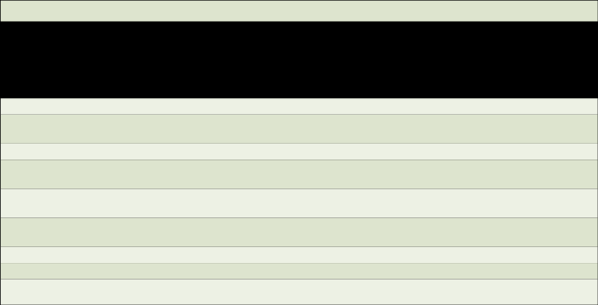  Jevsevar etal*60 | Livingstonetal63 | Laubenthal etal64 | Deslooval et al65 | Rowe et al62
Status, | Healthy | Healthy | Healthy | Healthy | Healthy
Gender, | (6 males, 5 females) | Women | Men | (9 males, 1 female) | Elderly
Age, and | Mean = 53 yr | Range 19–26 yr | Mean = 25 yr | Mean = 29 yr | Mean = 67 yr
Sample | n = 11 | n = 15 | n = 30 | n = 10 | n = 20
Activity | Mean (SD) | Means | Mean (SD) | Mean (SD) | Mean (SD)
Walk level surface | 63.1 (7.7) |  |  | 61.1 (5.0) | 64.5 (5.9)
Walk with |  |  |  | 57.7 (4.2)
crossover turn
Walk with sidestep |  |  |  | 57.5 (8.0)
Ascend stairs | 92.9 (9.4), 99 young  88 old | 83–105 | 83 (8.4) | 83.6 (5.3) | 80.3 (8.1)
Descend stairs | 86.9 (5.7), 90 young  84 old | 86–107 | 83 (8.2) | 56.1 (3.7) | 77.8 (8.3)
Rise from chair | 90.1 (9.8), 97 young  84 old |  |  | 81 (6.6) | 89.8 (9.4)
Sit in chair |  |  | 93 (10.3) |  | 91.0 (11.8)
Tie shoes |  |  | 106 (9.3)
Squat (deep) |  |  |  | 95.4 (25)

SD = Standard deviation.

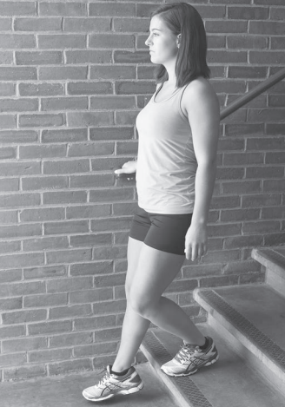
FIGURE 9.19 Descending stairs requires between 86 degrees and 107 degrees67 of knee flexion depending on the stair
dimensions.

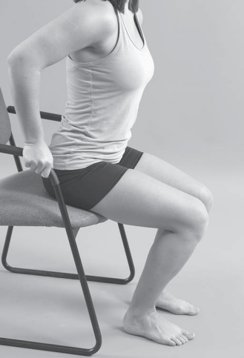
FIGURE 9.20 Rising from a chair requires a mean range of knee flexion of 90 degrees60 to 95 degrees.67

334 PART III Lower-Extremity Testing

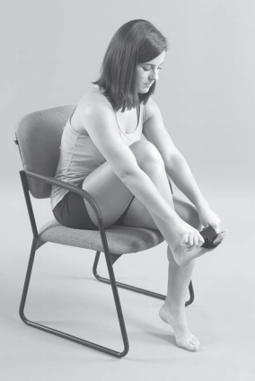
FIGURE 9.21 Putting on socks requires approximately 117 degrees of knee flexion.64

McFayden and Winter66 used stair dimensions of 22 cen- timeters for stair height and 28 centimeters for stair tread to determine the knee flexion ROM necessary to ascend and descend stairs. The ROM needed for ascending stairs ranged from 10 to 100 degrees and the ROM for descending stairs ranged from 20 to 100 degrees. Similar dimension stairs were used by Protopapadaki and associates,67 who used a rise height of 18 centimeters and a stair tread length of 28.5 cen- timeters to determine the knee motion during stair ascent and descent of 33 young healthy male and female subjects rang- ing in age from 18 to 39 years. The mean knee flexion angles were 93.9 degrees for stair ascent and 90.5 degrees for stair descent.
Lark and colleagues68 compared knee ROM in stair descent in six healthy elderly males (mean age = 64 years) and six height- and weight-matched young males (mean age = 25 years). Knee flexion ROM was 12% less in the elderly group than it was in the younger group, but there was no difference between the groups in knee extension. However, the elderly group used 80% to 100% of their passive knee ROM, whereas the younger males used only 70% to 80%.
Functional Knee Motions in Non-Western Cultures
Mullholland and Wyss69 reviewed the literature on the func- tional range of knee motions that are required in non-Western

cultures for normal activities of daily living. The review revealed that in many parts of Asia, chairs were not com- monly used and floor sitting, squatting, kneeling, or sitting cross-legged were the preferred positions (Figs. 9.22, 9.23, and 9.24). Hemmerich and colleagues70 used an electrogo- niometer motion-tracking device to determine the range of motion needed to perform squatting with the heels up and down, cross-legged sitting, and kneeling with ankles dor- siflexed and plantarflexed in 30 healthy Indian subjects (10 women and 20 men) with an average age of 48 years. Mean maximum knee flexion angles reached values greater than 150 degrees for both types of squatting and for kneel- ing with the ankles dorsiflexed. The mean maximal angle of knee flexion needed for kneeling with ankles plantarflexed was 144 degrees, whereas for squatting with the heels up was 157 degrees. Medial rotation at the knee accompanied hip flexion in all activities and was the greatest (33 degrees) during sitting cross-legged. The ranges of motion found in this study are far greater than can be accommodated by any existing prostheses and are many degrees more than the

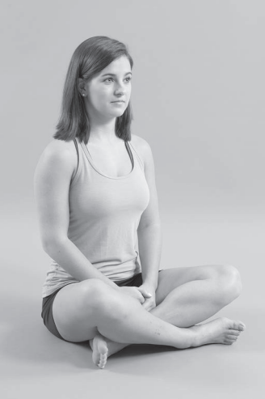
FIGURE 9.22 Cross-legged sitting requires about 33 degrees of medial knee rotation and about 37 degrees of lateral hip rotation.70

CHAPTER 9 The Knee 335

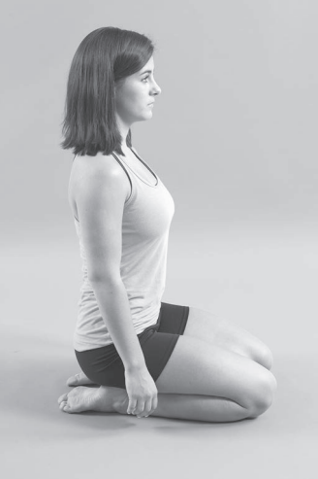
FIGURE 9.23 Kneeling with ankles plantarflexed requires knee flexion of approximately 144 degrees.70

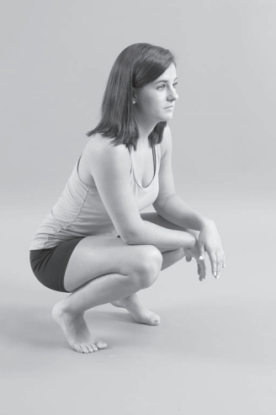
FIGURE 9.24 Squatting with heels up may require as much as
157 degrees of knee flexion.70

clinical guideline of 110 degrees of knee flexion suggested by both Rowe and associates62 and the AMA.11
Smith and colleagues71 identified an individual peak contact force of 49.7 N/kg during squatting at 149.9 degrees knee flexion. In comparison with stair climbing, the maxi- mum average joint contact forces during squatting activities occurred at significantly higher flexion angles.
Zhou and associates72 used an Optotrack Certus 3020 (three-dimensional) tracking system to measure the hip, knee, and ankle ROM during a typical kneeling posture assumed by healthy Chinese subjects. Fifteen males and 15 females with an average age of 24 years and 10 males and 10 females with an average age 64 years participated in the study. No differ- ences were found between the two age groups in the ROM required during kneeling (mean knee flexion was 140 and 141 degrees for the younger and older groups, respectively.
Kapoor and associates73 investigated the ROM required for cross-legged sitting, a posture essential to activities of daily living in Eastern and Asian cultures. Movements of the right hip,knee, and ankle joints were measured in 44 healthy

volunteers from the Indian population. Maximum knee flex- ion ranged from 126 degrees to 142 degrees with a mean of 135 degrees, which, like Zhou’s72 findings, was a ROM in excess of present clinical guidelines for knee arthroplasty.

Reliability and Validity of Range of Motion Measurement
Reliability studies of active and passive range of knee motion have been conducted in healthy subjects74–79 and in patient populations. Similar to findings at other joints, the results of knee studies show that usually intratester reliability is higher than intertester reliability. Reliability and ROM values also appear to be affected by measurement instruments and testing positions and by the type of motion (active or passive) tested. Factors that have been shown to improve reliability include training of testers, marking of landmarks, careful patient posi- tioning, use of more than one person to assist with stabiliza- tion (especially in the presence of spasticity), and assistance in holding of heavy extremities.

336 PART III Lower-Extremity Testing
Reliability of the Universal Goniometer in Healthy Populations
Boone and associates74 had four testers use universal goniom- eters (UG) to measure active knee flexion and extension ROM at four weekly sessions. Intratester reliability was higher than intertester reliability, and the total intratester SD for measure- ments at the knee was 4 degrees, whereas the intertester SD was 5.9 degrees. The authors recommended that when more than one tester measures the range of knee motion, changes in ROM should exceed 6 degrees to show that a real change has occurred.
Rheault and coworkers76 found good intertester reliabil- ity for the UG (Table 9.6) and the fluid-based inclinometer (r = 0.83) for measurements of active knee flexion. How- ever, significant differences in the ROM values were found between the instruments. Therefore, the authors concluded that although the universal and fluid-based goniometers each appeared to have good reliability, they should not be used interchangeably in the clinical setting.

Bartholomy, Chandler, and Kaplan77 had similar find- ings. These authors compared measurements of passive knee flexion ROM taken with a UG with measurements taken with a fluid-based inclinometer and an Optotrak motion- analysis system. Eighty healthy subjects aged 22 to 43 years were measured. Individually, the UG and the inclinometer were found to be reliable instruments for measuring passive knee flexion. Intraclass correlation coefficients (ICCs) for the UG were 0.97, and ICCs for the fluid inclinometer were 0.98. However, there were significant differences in the ROM values obtained among the three devices used, and the authors caution that these instruments should not be used interchangeably.
Mollinger and Steffan35 collected intratester reliabil- ity data on measurement of knee extension made by two testers using a UG. Intraclass correlation coefficients for repeated measurements of knee extension were high (see Table 9.6), with differences between measurements aver- aging 1 degree.


TABLE 9.6 Intratester and Intertester Reliability: Knee Flexion Range of Motion Measured With a Universal Goniometer

Author  Boone et al30 | N  12 | Sample  Healthy adult males | Motion  AROM ﬂexion | Intratester ICC  .87 | Intertester ICC  .50 | Intratester r | Intertester r
Brosseau et al78 | 60 | (25–54 yr)  Healthy  adults (mean age 20.6 yr) | Flexion ﬁxed angles | .86–.97 | .91–.94
Rheault et al76 | 20 | Healthy adults (mean age | AROM ﬂexion |  |  |  | .87
Gogia et al75 | 30 | 24.8 yr)  Healthy adults  (20–60 yr) | PROM ﬂexion |  | .99 |  | .98
Drews et al24 | 9 | Healthy infants (12 hr–6 days) | PROM ﬂexion |  |  |  | .69 left .89 right
Rothstein et al80 | 12 | Patients (ages not reported) | PROM  ﬂexion  extension | .97–.99 .91–.97 | .84–.99 .59–.80 | .97–.99 .91–.96 | .83–.92 .57–.79
Watkins et al81 | 43 | Patients (mean age 39.5 yr) | PROM  ﬂexion  extension | .99 .98 | .90 .86
Pandya et al82 | 150* 21† | Duchenne  muscular  dystrophy  (<1 yr–20 yr) | PROM  extension | .93 | .73
Mollinger and Steffan35 | 10 | Nursing home residents | Extension | .99 | .97

AROM = Active range of motion; ICC = Intraclass correlation coefﬁcient; PROM = Passive range of motion; r = Pearson product-moment correlation coefﬁcient.
*150 subjects were used to calculate intratester ICC.
†21 subjects were used to calculate intertester ICC.

CHAPTER 9 The Knee 337

Brosseau and associates78 used a UG and a parallel goni- ometer (PG) to measure two flexion-angle positions in the right knees of 60 healthy subjects (44 females and 16 males). Intratester reliability of the smaller-angle (about 20 degrees) and larger-angle (about 100 degrees) positions were good to excellent for the UG and good for the PG. Intertester reliabil- ity was lower than intratester reliability for both positions and goniometers; however, the smaller angle had lower intertester reliability compared with the large angle (see Table 9.6).
Peters and colleagues12 compared the use of a UG by two physical therapists to measure knee flexion and extension ROM with visual estimation (VE) by three physicians and with radiographic goniometry (RG) measurements. Radio- graphic measurements involved using a picture archive com- munication system for electronic medical imaging. Angles were determined using the long axis of the femur and tibia and estimated to the nearest degree through electronic goni- ometry. Twenty-one healthy male volunteers were randomly assigned to have either the right or left knee evaluated. Knee ROM examinations were repeated on 13 of the patients by three physicians and two physical therapists during separate sessions to allow for intrarater reliability evaluations. Radio- graphs of all 21 healthy volunteers were available for evalua- tion of agreement. All ICCs of intrarater reliability (VE, UG, and RG) for extension, flexion, and squat flexion (RG only) were acceptable. However, there was no agreement across methods. The authors attributed the lack of agreement todif- ferences in the training of orthopedists and physical therapists. The mean radiographic squat flexion ROM was 158 degrees, which is 14 more degrees than supine flexion and raises the question of whether supine flexionis an accurate measure of maximum range of motion.
Reliability of the Universal Goniometer in Patient Populations
Rothstein, Miller, and Roettger80 investigated intratester, intertester, and interdevice reliability in a study involving 12 patients referred to physical therapy for knee problems. Intratester reliability for passive ROM measurements for knee flexion and extension was high. Intertester reliability also was high among the 12 testers for passive ROM measurements for flexion but was lower for knee extension measurements (see Table 9.6). Intertester reliability was not improved by repeated measurements but was improved when testers used the same patient positioning. Interdevice reliability was high for all measurements. Neither the composition of the UG (metal or plastic) nor the size (large or small) had a significant effect on the measurements.
Watkins and associates81 compared passive ROM mea- surements of the knees of 43 patients made by 14 physical therapists who used a UG and VE. These authors found that intratester reliability with the UG was high for both knee flexion and knee extension. Intertester reliability for gonio- metric measurements also was high for knee flexion but only good for knee extension (see Table 9.6). Both intratester and intertester reliability were lower for VE than for goniometric

measurement. The authors suggested that therapists should not substitute VEs for goniometric measurements when assessing a patient’s range of knee motion because of the additional error that is introduced with use of visual estimation.
Pandya and colleagues82 studied intratester and inter- tester reliability of passive knee extension measurements in 150 children aged 1 to 20 years who had a diagnosis of Duchenne muscular dystrophy. Intratester reliability with use of the UG was high, but intertester reliability was only fair (see Table 9.6).
McWhirk and Glanzman83 had two physical therapists measure the knee ROM and the popliteal angle in 46 knees in 25 children (aged 2 to 18 years) with spastic cerebral palsy. The intertester reliability of knee extension measurements was an ICC of 0.78 with a 95% confidence interval (CI) = ±1.75, and the popliteal angle measurement had an ICC of 0.93 with a 95% CI = ±1.47. The therapists helped each other during the measurements by having one or the other either provide support for the test leg or stabilize the other extremity.
In a study by Lessen and associates,84 two physical thera- pists used a long-arm UG to measure active and passive knee flexion and extension in 30 patients within the first 4 days after total knee arthoplasty. Measurements were taken with the patients supine in a hospital bed and in the sitting posi- tion on an examination table. The highest levels of agreement between the testers were found for passive flexion and exten- sion in the sitting position. The lowest level of agreement was found for passive flexion in the supine position with 16.2 to 19.0 degrees difference between the two testers. Intraclass correlation coefficient values for intertester reliability were highest for active and passive flexion while sitting.
Kilgour, McNair, and Stott85 had three pediatric physi- cal therapists measure bilateral knee extension in 25 children with spastic cerebral palsy ranging in age from 6 to 17 years and 25 age- and sex-matched controls. Intrasessional absolute differences ranged from 0 to 2.7 degrees in the control group and 0 to 2.4 degrees in the cerebral palsy (CP) group. Intrases- sionalICCs were good in the control group (ICC = 0.79–0.87) and excellent in the CP group (ICC = 0.97–0.99). Interses- sional ICCs were lower for both the control and CP groups, but only the control group had unacceptable ICCs (0.34–0.67) compared with an ICC of 0.89 to 0.92 for the CP group. The authors concluded that sagittal plane ROM measures have similar levels of reliability in children with spastic CP com- pared with healthy controls both within and between sessions.
Reliability of the Inclinometer
The mean knee flexion ROM for the Ely test was 138.5 degrees for four testers using an inclinometer in a study by Piva and associates.86 Measurements were taken of 30 patients with patellofemoral pain syndrome ranging in age from 14 to 47 years. The intertester reliability ICC was 0.91.
In a study by Gnat and colleagues,18 three physical ther- apists used a pleurimeter attached to the lower leg at a point halfway between the apex of the patella and the line join- ing the two malleoli to measure knee ROM. A force gauge

338 PART III Lower-Extremity Testing
attached to the ankle was used to measure the amount of force needed to produce passive extension/flexion of the knees of 26 students. Interrater reliability for knee flexion had ICCs ranging from 0.85 to 0.95 with the standard error of measure- ments (SEMs) ranging from 2.3 to 3.8 and smallest detectable differences (SDDs) ranging from 6.4 to 10.5. Interrater reli- ability for knee extension had ICCs ranging from 0.88 to 0.97 and SEMs ranging from 2.4 to 3.8, with SDDs ranging from 6.4 to 10.4.
Rheault and coworkers76 investigated the concurrent validity of a UG and an inclinometer for measurements of active knee flexion. Each instrument had good validity, but instruments could not be used interchangeably.
Reliability of the Electronic Digital Inclinometer and Electrogoniometer
Cleffken and associates44 conducted a study to determine both intratester and intertester reproducibility for measurements of active and passive knee flexion and extension in 42 healthy male volunteers. Each motion was measured by two testers three times in four measurement sessions using the CYBEX ED1320, an electronic digital inclinometer. Measurements of passive maximum flexion of the knee resulted in a smaller detectable difference than active knee flexion for intertester comparisons. Intratester reliability showed better reproduc- ibility with SDDs reduced by 0.4 to 1.9 degrees over inter- tester values.
Piriyaprasarth and colleagues87 assessed intratester and intertester reliability of knee measurements using a flexi- ble electrogoniometer at two different fixed flexion angles (45 and 75 degrees) in sitting, supine, and standing positions. Thirty-seven healthy adults (mean age 31 years) participated in the intratester study, and 35 healthy adults (mean age 30 years) participated in the intertester reliability study. Ten repetitions of joint angles were taken by two testers. Intratester reliability of measurements ranged from fair for supine (ICC = 0.75–0.76), to good in sitting (ICC = 0.86–0.87), and in standing (ICC = 0.87–0.88). Intertester reliability was poor to fair for supine (ICC = 0.58–0.71), and for sitting (ICC = 0.68–0.79),and poor to good for standing (ICC = 0.57–0.80). The sitting position had higher ICCs and lower standard errors of measurement (SEMs) for both intratester and intertester reliability compared with the supine position. The SEM for repeated measures for the same tester was less than 1.7 degrees when the same tester repeated the measurements. One drawback of the study was that only angles less than 90 degrees were measured.
Reliability and Validity of Digital Imaging and Photography
Bennett and colleagues88 recorded four digital images of each of 10 subjects’ limbs in the following four positions: active extension, passive maximum extension, active flex- ion, and passive maximum flexion. A physical therapist and an orthopedic registrar independently measured each of the 40 images for interobserver reliability and the results were analyzed using Pearson product moment correlation coeffi- cients (r = 0.993 – 0.995). Intraclass correlation coefficients

ranged from 0.91 to 0.99 with SDs of 0.9 to 1.9 degrees. According to the authors, the advantages of using this tech- nique are that it does not rely on skin marks over bony land- marks, which are often only visualized and not marked. It also eliminates the need for therepositioning of the goniom- eter andrepalpation of bony landmarks that may be required when the overlying skin moves and alters the marking of the bony landmarks. Another advantage is that serial digital images can be made and rechecked. The major disadvantage is that it is relatively time consuming and both examiners were measuring from the same photograph, which isnottyp- ical in a clinical setting.
Naylor and associates89 evaluated the validity andreliabil- ity of measuring knee ROM using a goniometer in conjunc- tion with radiographs and photographs. Thirty-one volunteers (13 with arthritis and 18 healthy participants) were examined by three examiners using the following two methods of goni- ometer alignment: (1) the marker method using a skin marker on the greater trochanter, and (2) the line of femur method using estimation of the line of the femur. Day-to-day intrarater reliability for flexion and extension yielded high concordance correlation coefficients (CCCs) for all three examiners for both marker and line of femur methods, with slightly greater CCCs for flexion. Interrater reliability of goniometer measurements of photographs had slightly higher coefficients for flexion compared with extension and for the marker method compared with the line of femur method. For both intra- and interreliabil- ity, the mean differences were within 2 degrees and 95% limits of agreement were generally acceptable (within 5 degrees) for both methods. The authors concluded that photography offers a superior method of measurement over standard goniometry including a permanent record, which provides greater transpar- ency and opportunities to confer.
Verhagen and associates90 compared digital photographs with a plastic 360-degree UG with 20-centimeter arms to measure knee motion in maximal flexion and extension in 49 patients. Results showed higher intraobserver reliability for the photographic method in flexion and extension compared with traditional goniometry. For both methods, intraobserver reliability for extension was lower compared with flexion. Intraobserver SEM of the digital method was smaller than the UG method. The authors concluded that measuring maximum flexion and extension on digital photographs was more reli- able than standard goniometry.
Krause and colleagues91 examined the reliability of the Coaches Eye, a two-dimensional motion-analysis tablet computer application (app), for goniometric assessment of sagittal plane hip, knee, and ankle motion during the FMS (Functional Movement System) deep squat. (FMS is a bat- tery of seven fundamental movement tests used to evaluate and categorize functional movement patterns.) A secondary objective was to compare ROM values obtained with the 3D Vicon motion-analysis program. Twenty-six healthy individ- uals aged 21 to 26 years participated in the study. Reliability of measurement ranged from 0.62 to 0.88 for the motion- analysis system and from 0.79 to 0.098 for the app. The MDC

CHAPTER 9 The Knee 339

using the app was 6 degrees at the knee. The mean knee angle was 114 degrees and the ICC was 0.96. The authors con- cluded that the Coaches Eye app provides a reliable means of assessing sagittal plane kinematics during a deep squat maneuver.
Reliability of the Rotameter and Rottameter
A limited number of studies and instruments exist to measure voluntary knee rotation. Tsai and colleagues15 at the Univer- sity of Pittsburgh developed a device called the Rotameter to measure passive internal and external rotation at the knee. The device consists of a foam walker boot with a force/moment sensor affixed to the sole of the boot, which is used in con- junction with a magnetic tracking system. The device was tested on 11 subjects. Intratester reliability within one testing session with knee angles of 30 and 90 degrees of knee flexion found that the ICCs were both greater than 0.95 with associ- ated SEMs less than 1 degree and a 95% confidence inter- valless than 2.0 degrees. Intertester reliability at 90 degrees of flexion had average ICCs and SEMs of 0.88 and 1.6, respectively.
Almquist and colleagues16 examined the within-day and 1 week apart intratester reliability of an external device called the Rottameter. The ICCs ranged from 0.50 to 0.94 at all three flexion angles (90, 60, and 30 degrees) with 6 and 9 Nm of applied torque. A physiotherapist measured both knees in 10 healthy adults (6 females and 4 males), once in the morn- ing and once in the afternoon of the same day. Another group of 10 females and males were tested 1 week apart at the same time of day. The highest within-day ICC was calculated at 0.94 Nm of applied torque at a 30-degree flexion angle. Intert- ester reliability was measured by two independent physiother- apists and the highest ICC was 0.87 at 90 degrees and 0.61 to 0.70 at 30 degrees at 6 Nm of applied torque. The Rottame- ter was judged by the authors to be a good (ICC = 0.75) to excellent (ICC above 0.75) device concerning reliability for measuring knee rotation with 6 and 9 Nm of applied torque at the three knee angles. The ROM for total rotations at 9 Nm of applied torque was 70 degrees to 79 degrees as measured by the Rottameter. The main drawback of this device is that it is not easily transported because it is a heavy wooden box-like structure and is a prototype.
Desloovere and colleagues65 measured knee joint motion in three anatomical planes in 10 volunteers during 11 motor tasks using a gait-analysis technique. The authors found that the sidestep turn and descending a step showed that knee joint rotations were significantly larger by 8 to 9 degrees than during standard walking but still very repeatable. The results also showed that turning increases knee axial rotation significantly. Axial ROM in the range of 18 to 24 degrees was observed in the present study for 90-degree turning tasks, which was significantly greater than for normal walking.
Reliability and Validity of Smartphone Applications
Jenny92 used a smartphone application to measure knee flexion angles taken during 10 total knee arthroplasties that were being performed on 4 men and 6 women (mean age of

69 years) with end-stage knee osteoarthritis. The smartphone was encased in a sterile plastic bag and placed as follows: one on the anterior surface of the thigh proximal to the skin incision and the other on the anterior surface of the distal tibia slightly distal to the incision. The knee was positioned according to the navigated system at six positions starting at full extension and ending at maximal flexion. Therefore, six navigated and six smartphone measurements were obtained for each patient giving a total of 60 navigated and 60 smartphone measure- ments. Results showed that there was a significant correla- tion between the navigated and smartphone measurements of all individual patients (r2 = 0.88–0.99) that were operated on and the mean paired difference between the application and the navigation system was not significant (−1.1 degrees, ±6.8 degrees). Results showed that the coherence between both measurements was good. See Table 9.7.
Ockendon and Gilbert93 compared a smartphone accel- erometer-based knee goniometer with a long-armed conven- tional goniometer for the assessment of a fixed knee deformity. Five healthy males aged 30 to 40 years were studied. The smartphone goniometer had an intraobserver correlation of r = 0.98 compared with r = 0.95 for the UG. The smartphone goniometer had an interobserver correlation of r = 0.98 com- pared with r = 0.93 for the UG. The authors concluded that the smartphone goniometer is a reliable device for measurement of knee flexion in the clinic.
Ferriereo and colleagues94 assessed the reliability of a smartphone-based application (Dr. Goniometer) developed for photographic-based goniometry by comparing the smart- phone application’s measurements of knee joint angles with measurements taken with a UG. In Part I, four raters per- formed repeated measurements with both the smartphone app and the UG at different fixed knee angles. The intrarater ICC was 0.95 and the interrater ICC was 0.99. In Part II, 10 other raters measured photographs of the knee at different flex- ion angles ranging from 20 to 145 degrees on a battery of 35 photographs. The results showed that inter- and intrarater correlations were always more than 0.96. However, according to the authors both UG and photographic angle goniometry are more reliable with greater degrees of knee flexion. Agree- ment between Dr. Goniometer and the UG showed a width of 18.2 degrees (95% limits of agreement [LOA]) (LOA = −7.5/+10.7 degrees) and 14.1 degrees (LOA = −6.6/+7.5). The authors concluded that because the smartphone app appears to be a reliable method for measuring knee ROM, it could be used as an alternative or additional method of knee joint measurement. It is easier to use than other photographic-based joint ROM assessments.
Validity of the Universal Goniometer
Validity of knee measurements in the following studies has been determined by comparison of UG measurements with radiographs. Gogia and colleagues75 measured knee joint angles between 0 and 120 degrees of flexion. These measure- ments were immediately followed by radiographs. Intertester reliability was high (Table 9.6). The ICC for validity also was

TABLE 9.7 Intratester and Intertester Reliability of a Digital Inclinometer, Universal Goniometer, Digital Photography Imaging, and Smartphone Applications

Study  Bennett et al88 | N  10 patients (7 females, 3 males) | Raters  2 raters; PT, and orthopedic registrar | Methods  Gravity digital inclinometer Digital imaging | Motions  AROM extension PROM extension AROM ﬂexion  PROM ﬂexion | Intrarater ICC  .90 .95 .99 .99 | Interrater ICC  .99 .95 .99 .99
Cleffken et al44 | 42 healthy males Mean age 22.1 | 2 raters | Electronic gravity digital inclinometer, in supine position with hip ﬂexed to 20 degrees | AROM ﬂexion  PROM ﬂexion  AROM extension | r = .83 .87  .94 | r = .83 .83  .94
Ferriero93 |  | 4 raters: 2 PTs, 2 student PTs, plus 10 additional raters | Smartphone app  (Dr. Goniometer)  Universal goniometer | Fixed knee positions  Battery of 32 photos with ﬁxed knee positions  20–145 degrees | .96  .99 | .99  .99
Jenny91 | 10 (4 males, 6 females)  patients aged 57–81 yr having total knee  arthroplasty | Operating surgeon and assistant surgeon | Smartphone app (Angle, Smudge) Navigation System (OrthoPilot,  Aesculap, Tuttlingen) | Fixed knee ﬂexion positions | .81 | .79
Peters  et al12 | 21 healthy male volunteers Mean age 29.6 yr | 3 MDs  2 PTs  3 MDs | Visual estimation  Universal goniometry  Radiographic goniometry | Flexion  Extension Flexion  Extension Flexion  Extension | .96 .95 .97 .85 .94 .87 | .80 .80 .88 .21 .99
Naylor89 | 31 (13 arthritic, 18 healthy) Mean age: 33.8 yr | 3 raters using 2 methods | Line of femur method Marker method | Flexion  Extension Flexion  Extension | .99 .99 .99 .98 | .99 .89 .99 .98
Okendon92 | 5 healthy males 30–40 yrs | 2 experienced raters | Smartphone application Universal goniometer | Fixed knee ﬂexion positions | r = 0.98 .94 | .99 .95
Verhagen90 | 49 patients with various medical histories | 4 raters | Digital photographs and goniometric measurements | Goniometry ﬂexion Digital ﬂexion  Goniometry extension Digital extension | .95 .99 .82 .84 | .92 .96 .64 .65
ICC = Intraclass correlation coefﬁcient; r = Pearson product-moment correlation coefﬁcient; AROM = Active range of motion; PROM = Passive range of motion; PT = physical therapist or physiotherapist; MD = medical doctor.

340 PART I I I Lower-Extremity Testing

CHAPTER 9 The Knee 341

high (0.99). The authors concluded that the knee angle mea- surements taken with a UG were both reliable and valid.
Enwemeka79 compared the measurements of six knee joint positions (0, 15, 30, 45, 60, and 90 degrees) taken with a UG with bone angle measurements provided by radiographs. The measurements were taken on 10 healthy adult volunteers (4 women and 6 men) between 21 and 35 years of age. The mean differences ranged from 0.52 to 3.81 degrees between gonio- metric and radiographic measurements taken between 30 and 90 degrees of flexion. However, mean differences were higher (4.59 degrees) between goniometric and radiographic measure- ments of the smaller knee joint angles between 0 and 15 degrees. Ersoz and Ergun37 used a UG with 25-centimeter arms and 1-degree increments to measure the ROM in both knees of 20 patients with bilateral knee osteoarthritis. Radiographs were taken of tibiofemoral, lateral tibiofemoral, and patellofemoral compartments of the same knees. The authors found a clear relationship between knee ROM measurements of flexion, extension, and medial and lateral rotation taken with a UG and radiographs. For example, limitations in internal rotation ROM provided a prediction of advanced disease in the lateral knee compartment. The authors concluded that measurements
of joint ROM were helpful in the determination of the com- partment or compartments that were affected by the disease process.
Brousseau and associates78 measured active knee flexion in two positions in 60 healthy university students (44 females and 16 males) with a mean age of 21 years. Two trained tes- ters alternately used either a universal (UG) or a parallelogram (PG) goniometer for the measurements. Eight measurements were taken with the knee flexed in the supine position and eight with the knee in the first 20 degrees of flexion in the supine position. A radiograph was taken of each subject in each knee position. Criterion validity was determined by calculating Pearson product moment correlation coeffi- cients between each goniometric and radiologic measure- ment. Results showed that both the PGs and UGs had higher validity when measuring the larger fixed knee flexion angle

compared with the smaller angle when using radiographs as the gold standard. Naylor and associates89 found that valid- ity of photographs referenced to radiographs showed that for each of the following (line of the femur and marker meth- ods) all three examiners yielded very high CCCs for flexion (0.98–0.99) and moderate to substantial CCCs for extension (0.48–0.68). Mean differences and 95% limits of agreement were narrower for flexion than for extension. The authors con- cluded that measuring ROM from a photograph has excellent validity for flexion, whereas the validity for extension was less impressive.

Reliability and Validity of Muscle Length Testing
Gajdosik and associates,19 in a study of 30 healthy males aged 18 to 40 years, found that intrarater reliability intra- class correlation coefficients (ICCs) for the knee extension test were 0.86 when knee extension was performed actively and 0.90 when performed passively. Youdas and colleagues20 conducted a study to examine the effects of age and gender on hamstring muscle length (HML) as measured by passive straight leg raise and popliteal angle. The study consisted of 214 adults (108 women and 106 men) between the ages of 20 and 79 years. The trunk–thigh angle (PSLR) and the PA (thigh–leg angle) were estimated with a goniometer. Results showed that HML differed significantly between genders, with females demonstrating greater flexibility than their male counterparts. According to the data, the mean value of PSLR for women of 76.3 was closer to 80 degrees than the value for men of 68.5 degrees. The PSLR angle in men was signifi- cantly less than that in women.
Gnat and colleagues18 calculated correlation coefficients, standard errors of measurement, and smallest detectable dif- ference to evaluate reliability of the passive knee extension (PKE) test for length of the hamstring muscles. The results showed excellent reliability. The mean interrater ICC for the PKE test was 0.93.



35. Mollinger, LA, and Steffan, TM: Knee ﬂexion contractures in institu- tionalized elderly: Prevalence, severity, stability and related variables. Phys Ther 73:437, 1993.
R E F E R E N C E S
1. Levangie, PK, and Norkin, CC: Joint Structure and Function: A Compre- hensive Analysis, ed 5. FA Davis, Philadelphia, 2011.
2. Williams, PL (ed): Gray’s Anatomy, ed 38. Churchill Livingstone, New York, 1995.
3. Mossberg, KA, and Smith, LK: Axial rotation of the knee in women. J Orthop Sports Phys Ther 4:27, 1983.
4. Zarins,B, et al: Rotational motion of the knee. Am J Sports Med 11:152, 1983.
5. Almquist, PO, et al: Knee rotation in healthy individuals related to age and gender. J Orthop Res 31(1):23, 2013.
6. Kaltenborn, FM: Mobilization of the Extremity Joints, ed 5. Olaf Norlis Bokhandel, Oslo, Norway, 1999.
7. Cyriax,JH, and Cyriax, PJ: Illustrated Manual of Orthopaedic Medicine. Butterworths, London, 1983.
8. Fritz, JM, et al: An examination of the selective tissue tension scheme, with evidence for the concept of a capsular pattern of the knee. Phys Ther 78:1046, 1998.
9. Boone, DC, and Azen, SP: Normal range of motion of joints in male subjects. J Bone Joint SurgAm 61:756, 1979.
10. Roach, KE, and Miles, TP: Normal hip and knee active range of motion: The relationship to age. Phys Ther 71:656, 1991.
11. Rondinell, RD (ed): Guides to the Evaluation of Permanent Impairment, ed 6. American Medical Association, Chicago, 2009.
12. Peters, PG, et al: Knee range of motion: Reliability and agreement of
3 measurement methods. Am J Orthop 40(12):E249, 2011.
13. Alam, M, et al: A clinical device for measuring internal-external rota- tional laxity of the knee. Am J Sports Med 41(1):87, 2013.
14. Ahrens, P, et al: A novel tool for objective assessment of femorotibial rotation: A cadaver study. IntOrthop 35 (11):1611, 2011.
15. Tsai, AG, et al: Rotational knee laxity: Reliability of a simple measure- ment device in vivo. BMC Musculoskelet Disord 9:35, 2008.
16. Almquist, PO, et al: Measurements of knee rotation-reliability of an external device in vivo. BMC Musculoskelet Disord 12:291, 2011.
17. Clarkson, HM: Musculoskeletal Assessment Joint Motion and Muscle Testing, ed 3. Walters Klower Lippincott William and Wilkins, Philadel- phia, 2013.
18. Gnat, R, et al: Reliability of the passive knee ﬂexion and extension tests in healthy subjects. J Manipulative Physiol Ther 33:659, 2010.
19. Gajdosik, RL, et al: Comparison of four clinical tests for assessing ham- string muscle length. J Orthop Sport Phys Ther 18:614, 1993.
20. Youdas, JW, et al: The inﬂuence of gender and age on hamstring muscle length in healthy adults. J Orthop Sports Phys Ther 35:246, 2005.
21. Fredriksen, H, et al: Passive knee extension test to measure hamstring muscle tightness. Scand J Med Sci Sports 7:279, 1997.
22. Rothstein, JM, Roy, SH, and Wolf, SL: The Rehabilitation Specialist’s Handbook, ed 2. FA Davis, Philadelphia, 1998
23. Waugh, KG, et al: Measurement of selected hip, knee, and ankle joint motions in newborns. Phys Ther 63:1616, 1983.
24. Drews, JE, Vraciu, JK, and Pellino, G: Range of motion of the lower extremities of newborns. PhysOccup Ther Pediatr 4:49, 1984.
25. Schwarze, DJ, and Denton, JR: Normal values of neonatal limbs: An evaluation of 1000 neonates. J Pediatr Orthop 13:758, 1993.
26. Wanatabe, H, et al: The range of joint motions of the extremities in healthy Japanese people: The difference according to age. Nippon Seikeigeka Gakkai Zasshi 53:275, 1979. (Cited by Walker, JM: Musculo- skeletal development: A review. Phys Ther 71:878, 1991.)
27. Broughton, NS, Wright, J, and Menelaus, MB: Range of knee motion in normal neonates. J Pediatr Orthop 13:263, 1993.
28. Boone, DC: Techniques of measurement of joint motion. (Unpublished supplement to Boone, DC, and Azen, SP: Normal range of motion in male subjects. J Bone Joint SurgAm 61:756, 1979.)
29. Beighton, P, Solomon, L, and Soskolne, CL: Articular mobility in an African population. Ann Rheum Dis 32:23, 1973.
30. Cheng, JC, Chan, PS, and Hui, PW: Joint laxity in children. J Pediatr Orthop 11:752, 1991.
31. Steinberg, N, et al: Range of joint movement in female dancers and non- dancers aged 8–16 years. Am J Sports Med 34(5):814, 2006.
32. Soucie,JM, et al: Range of motion measurements reference values and a database for comparison studies. Haemophilia, 17(3):500, 2011.
33. Walker, JM, et al: Active mobility of the extremities in older subjects. Phys Ther 64:919, 1984.
34. Greene,WB, and Heckman, JD (eds): The Clinical Measurement of Joint Motion. American Academy of Orthopaedic Surgeons, Chicago, 1994.
36. Steultjens, MPM, et al: Range of motion and disability inpatients with osteoarthritis of the knee or hip. Rheumatology 39:955, 2000.
37. Ersoz,M, and Ergun, S: Relationship between knee range of motion and Kellgren-Lawrence radiographic scores in knee osteoarthritis. Am J Phys Med Rehabil 82:110, 2003.
38. Escalante,A, et al: Determinants of hip and knee ﬂexion range: Results from the San Antonio Longitudinal Study of Aging. Arthritis Care Res 12:8, 1999.
39. Nonaka, H, et al: Age-related changes in the interactive mobility of the hip and knee joints: A geometrical analysis. Gait Posture 15:236, 2002.
40. Macedo, LG, and Magee, DJ: Effects of age on passive range of motion of selected peripheral joints in healthy adult females. Physiother Theory Pract 25(2):146, 200.
41. Loudon, JK, Goist, HL, and Loudon, KL: Genu recurvatum syndrome. J Orthop Sports Phys Ther 27:361, 1998.
42. Hall, MG, et al: The effect of hypermobility syndrome on knee joint pro- prioception. Br J Rheumatol 34:121, 1995.
43. James,B, and Parker, AW: Active and passive mobility of the lower limb joints in elderly men and women. Am J Phys Med Rehabil 68:162, 1989.
44. Cleffken, B, et al: Digital goniometric measurement of knee joint motion. Evaluation of usefulness for research settings and clinical practice. Knee 14:385, 2007.
45. Jasmuheen.com (http://www.who.int/mediacentre/factsheets/fs311/en/index .html).
46. Lichtenstein, MJ, et al: Modeling impairment: Using the disablement process as a framework to evaluate determinants of hip and knee ﬂexion. Aging (Milano) 12:208, 2000.
47. Sobti,A, et al: Occupational physical activity and long term risk of mus- culoskeletal symptoms: A national survey of post ofﬁce pensioners. Am J Indust Med 32:76, 1997.
48. Park,W, et al: Obesity effect on male active joint range of motion. Ergo- nomics 53(1):102, 2010.
49. Grotle,M, Hagen, KB, and Natvig, B: Obesity and osteoarthritis in knee, hip and hand. An epidemiological study in the general population with ten years follow up. BMC Musculoskelet Disord 9:132, 2008.
50. Richmond, SA, et al: Are joint injury, sport activity, physical activity, obesity or occupational activities predictors for osteoarthritis?A system- atic review. J Orthop Sports Phys Ther 43(8):515, 2013.
51. Widmyer, MR, et al: High body mass index is associated with increased diurnal stains in articular cartilage of the knee. Arthritis Rheum 65(10):2615, 2013.
52. Vrezas, J, et al: Case control study of knee osteoarthritis and lifestyle factors considering their interaction with physical workload. Arch Occup Environ Health 83(3):291, 2010.
53. Jensen, LK, Rytter, S, and Bonde, JP: Symptomatic knee disorders in ﬂoor layers and graphic designers. A cross-sectional study. BMC Muscu- loskelet Disord 113:188, 2012.
54. Amin, S, et al: Occupation-related squatting, kneeling, and heavy lifting and the knee joint: A magnetic resonance imaging-based study in men. J Rheumatol 35(8), 2008.
55. Sowers, MF, et al: BMI versus body composition and radiographically deﬁned osteoarthritis of the knee in women: A 4-year follow-up study. Osteoarthritis Cartilage 16:367, 2008.
56. Seidler, A, et al: The role of cumulative physical work load in sympto- matic knee osteoarthritis—a case control study. J Occup Med Toxicol 14, 2008.
57. Teichtahl,AJ, et al: Occupational activity is associated with knee carti- lage morphology in females. Maturitas 66(1):72, 2010.
58. Palmu, SA, et al: Childhood femoral fracture can lead to premature knee joint arthritis. Acta Orthop 84(1):71, 2013.
59. McCarthy, I, et al: Analysis of knee ﬂexion characteristics and how they alter with the onset of knee osteoarthritis. A case control study. BMC Musculoskelet Disord 14: 169, 2013.
60. Jevsevar, DS, et al: Knee kinematics and kinetics during locomotor activ- ities of daily living in subjects with knee arthroplasty and in healthy control subjects. Phys Ther 73:229, 1993.
61. Oberg, T, Karsznia,A, and Oberg, K: Joint angle parameters in gait: Ref- erence data for normal subjects, 10–79 years of age. J Rehabil Res Dev 31:199, 1994.
62. Rowe, PJ, et al: Knee kinematics in gait and other functional activities measured using ﬂexible electrogoniometry: How much knee motion is sufﬁcient for a normal daily life? Gait Posture 12:143, 2000.

CHAPTER 9 The Knee 343

63. Livingston, LA, Stevenson, JM, and Olney, SJ: Stairclimbing kinemat- ics on stairs of differing dimensions. Arch Phys Med Rehabil 72:398, 1991.
64. Laubenthal, KN,Smidt, GL, and Kettlekamp, DB: Aquantitative analysis of knee motion during activities of daily living. Phys Ther 52:34, 1972.
65. Desloovere, K, et al: Range of motion and repeatability of knee kine- matics for 11 clinically relevant motor tasks. Gait Posture 32(4):597, 2010.
66. McFayden, BJ, and Winter, DA: An integrated biomechanical analysis of normal stair ascent and descent. J Biomech 21:733, 1988.
67. Protopapadaki,A, et al: Hip, knee and ankle kinematics and kinetics dur- ing stair ascent and descent in healthy young individuals. Clin Biomech 22:203, 2007.
68. Lark, SD, et al: Knee and ankle range of motion during stepping down in elderly compared to young men. Eur J ApplPhysiol 9:287, 2004.
69. Mulholland, SJ, and Wyss, UP: Activities of daily living in non-Western cultures: Range of motion requirements for hip and knee joints. Int J Rehabil Res 24:191, 2001.
70. Hemmerich, A, et al: Hip, knee and ankle kinematics of high range of motion activities of daily living. J Orthop Res 24:770, 2006.
71. Smith, SM, et al: Tibiofemoral contact forces and knee kinematics during squatting. Gait Posture 27(3):376, 2008.
72. Zhou, H, et al: Kinematics of the hip, knee, ankle of the young and elderly Chinese people during kneeling activity. J Zhejiang Univ Sci B 13(10):831, 2012.
73. Kapoor, A, et al: Range of movements of lower limb joints in cross- legged sitting. JArthroplasty 23(3):451, 2008.
74. Boone, DC, et al: Reliability of goniometric measurements. Phys Ther 58:1355, 1978.
75. Gogia, PP, et al: Reliability and validity of goniometric measurements at the knee. Phys Ther 67:192, 1987.
76. Rheault, W, et al: Intertester reliability and concurrent validity of ﬂuid based and universal goniometers for active knee ﬂexion. Phys Ther 68:1676, 1988.
77. Bartholomy, JK, Chandler, RF, and Kaplan, SE: Validity analysis of ﬂuid goniometer measurements of knee ﬂexion [abstract]. Phys Ther 80:S46, 2000.
78. Brosseau,L, et al: Intratester and intertester reliability and criterion valid- ity of the parallelogram and universal goniometers or active knee ﬂexion in healthy adults. Physiother Res Int 2:150, 1997.

79. Enwemeka, CS: Radiographic veriﬁcation of knee goniometry. Scand J Rehabil Med 18:47, 1986.
80. Rothstein, JM, Miller, PJ, and Roettger, RF: Goniometric reliability in a clinical setting. Phys Ther 63:1611, 1983.
81. Watkins, MA, et al: Reliability of goniometric measurements and visual estimates of knee range of motion obtained in clinical settings. Phys Ther 71:90, 1991.
82. Pandya,S, et al: Reliability of goniometric measurements inpatients with Duchenne muscular dystrophy. Phys Ther 65:1339, 1985.
83. McWhirk, LB, and Glanzman, AM: Within-session inter-rater reliability of goniometric measures inpatients with spastic cerebral palsy. Pediatr Phys Ther 18:262, 2006.
84. Lessen, AF, et al: Reproducibility of goniometric measurement of the knee in the in-hospital phase following total knee arthroplasty. BMC Musculoskelet Disord 8:83, 2007.
85. Kilgour, G, McNair, PM, and Stott, NS: Intrarater reliability of lower limb sagittal range-of-motion measures in children with spastic diplegia. Dev Med Child Neurol 45:391, 2003.
86. Piva, SR, et al: Reliability of measures of impairments associated with patellofemoral pain syndrome. BMC Musculoskelet Disord 7:33, 2006.
87. Piriyaprasarth, P, et al: The reliability of knee joint position testing using electrogoniometry. BMC Musculoskelet Disord 9:6, 2008.
88. Bennett,D, et al: Measurement of joint motion using digital imaging. Int Orthop 33(6):1627, 2009.
89. Naylor, JM, et al: Validity and reliability of using photography for mea- suring knee range of motion: A methodological study. BMC Musculoske- let Disord 12:77, 2011.
90. Verhagen, F, et al: Are clinical photographs appropriate to determine the maximal range of motion of the knee range of motion? Acta OrthopBelg 76(6), 2010.
91. Krause, D, et al: The reliability and accuracy of a goniometer mobile device application for video measurement of the functional movement screen deep squattest. Int J Sports Phys Ther 10:37, 2015.
92. Jenny, J-Y: Measurement of knee ﬂexion angle with a smartphone appli- cation is precise and accurate. JArthroplasty 28:784, 2013.
93. Ockendon,M, and Gilbert, RE: Validation of a novel smartphone acceler- ometer-based knee goniometer. J Knee Surg 25(4):341, 2012.
94. Ferreiro,G, et al: Reliability of a smartphone-based goniometer for knee goniometry. Int J Rehabil Res 36(2), 2013.

